6CS012 – Artificial Intelligence and Machine Learning.
Lecture – 09
Introduction to Natural Language Processing. Sequence to Sequence Learning.
Siman Giri {Module Leader – 6CS012}
4/20/2025 Lec -09- Recurrent Neural Network and Seq - Seq Learning. 1
What we Built?
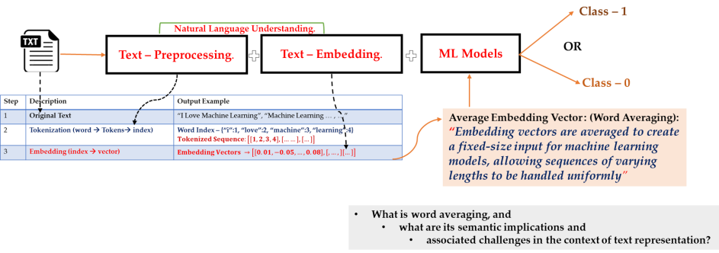4/20/2025 Lec -09- Recurrent Neural Network and Seq - Seq Learning. 2
Challenge – 1 – Text Data.
• Texts Data are Inherently Sequential:
• The meaning of a sentence depends not only on the individual words used but also on the specific order in which they appear.
• Language has grammar, structure, and context, all of which rely on this sequence.
• For example:
• The sentences: “The dog chased the cat.” and “The cat chased the dog.” contain the same words but the meaning is completely different due to the change in word order.
• words like “not” or “but” can flip or contrast the sentiment of a sentence depending on where they appear.
• In natural language or Text data , context accumulates word by word i.e.
• what we read or hear next often depends on what came before.
• This makes text a temporal or ordered data type much like time series or audio signals.
• Thus, preserving and modelling the sequential nature of text is essential for understanding meaning, emotion, intent and other linguistic feature.
• How does ML models handle this? Do they even consider this?
4/20/2025 Lec -09- Recurrent Neural Network and Seq - Seq Learning. 3
How do ML handle this? Word Averaging.
• Idea of Word Averaging or Embedded Vector Averaging:
• Word averaging is a simple way to represent a full sentence (sentence level embedding) or document as a single vector by:
• Looking up the embedding vector (e.g., from Word2Vec) for each word in the sentence.
• Taking the average (mean) of all those vectors.
• Using that average vector as the feature representation for the whole sentence.
• Example: For sentence – “I Love NLP.”
• Let’s assume following is 3-D word2vec representation (just for an example):
4/20/2025 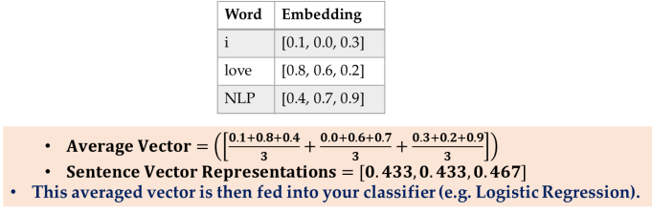Lec -09- Recurrent Neural Network and Seq - Seq Learning. 4
Pros and Limitations of word averaging …
Pros
• Simple and fast to implement.
• Works reasonably well with small datasets. • Reduces variable-length text to a fixed-size vector.
Limitations
• Losses word order:
• “I love NLP” and “NLP loves I” produce the same average:
• no difference in meaning.
• Ignores important words:
• Every word contributes equally no attention to negation to sentiment heavy words
• No context sensitivity:
• Words are used in isolation, the meaning of “bank” in “river bank” vs. “money bank” is the same.
4/20/2025 Lec -09- Recurrent Neural Network and Seq - Seq Learning. 5
Alternate to word averaging …
• We can conclude that:
• Preserving and modeling the sequential nature of text is essential for understanding meaning, emotion, intent, and other linguistic features
• Something that traditional machine learning models struggle with unless we manually craft features to capture such order.
• Way forward:
• Can we design a Neural Networks such that it can handle sequence property, making them highly effective for text-based tasks like sentiment analysis, translation and question answering.
4/20/2025 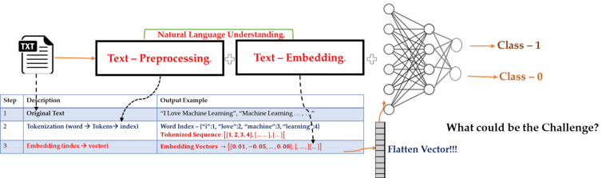Lec -09- Recurrent Neural Network and Seq - Seq Learning. 6
Limitations of FCN for Text.
• No word order awareness:
• No memory or context – Can not retain previous words ,
• Treats input as a flat vector.
• Misses long – term dependencies (e.g. subject – verb agreement)
• Thus, can not handle the sequential nature of text data.
• Fails to distinguish: “cat chased mouse” vs. “mouse chased cat”.
• Fixed Input Size – (Manual Features Extraction) : • Depends on handcrafted feature inputs like word averaging.
• Loses structure and syntax
• Requires padding or truncations to manage variable input size.
• Can lose or distort important information. • Ignores word position:
• Process all words equally
• May miss nuances like “not good” vs “good not”.
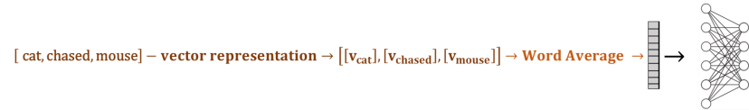4/20/2025 Lec -09- Recurrent Neural Network and Seq - Seq Learning. 7
Overcoming FCN limitations
• To address these challenges, we need to redesign the neural network architecture to: • Handle variable length input sequences
• Preserve the order of words in text
• Eliminate the need for input averaging
• Capture contextual and sequential dependencies
• This leads to sequence models like:
• RNNs, LSTMs, GRUs and modern Transformer.
4/20/2025 Lec -09- Recurrent Neural Network and Seq - Seq Learning. 8
1. Neural Network for Sequential Input. { “The Model for Text Data.”}
4/20/2025 Lec -09- Recurrent Neural Network and Seq - Seq Learning. 9
1.1 Neural Network for Sequential Input.
• Sequential Input means input must be in order i.e.
• ["cat", "chased", "mouse"] ≠ ["mouse", "chased", "cat"]
• What changes can we make in this architecture so that it is able to use previous information? 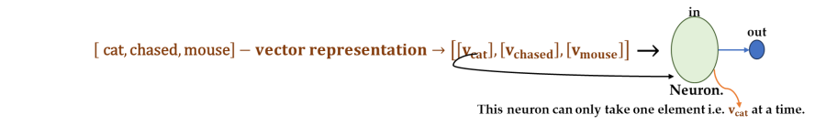
4/20/2025 Lec -09- Recurrent Neural Network and Seq - Seq Learning. 10
1.1 Neural Network for Sequential Input.
• Sequential Input means input must be in order i.e.
• ["cat", "chased", "mouse"] ≠ ["mouse", "chased", "cat"]
• What changes can we make in this architecture so that it is able to use previous information? 4/20/2025 Lec -09- Recurrent Neural Network and Seq - Seq Learning. 11
1.2 Sequential Input: Neurons with Recurrence. 4/20/2025 Lec -09- Recurrent Neural Network and Seq - Seq Learning. 12
1.3 Recurrent Neural Network: Introduction.
• A Recurrent Neural Network (RNN) is a class of artificial neural networks designed to process sequential data by maintaining a hidden state that captures information about previous elements in the sequence.
• At each time step , an RNN takes an input vector (word embedding) and combines it with the previous hidden state to produce a new hidden state:
• ���� = ���� ��_{��−��}, ����
• ���� → input at time step t.
• ��_{��−��} → previous hidden state old state.
• �� → learned weights or parameters.
• ���� → �������� mapping function with parameters ��: ���� → ����.
4/20/2025 Lec -09- Recurrent Neural Network and Seq - Seq Learning. 13
1.4 A “vanilla” RNN.
• aka “simple” RNN or “Elman” RNN after Jefferey Elman.
• A vanilla RNN, updates its hidden state by combining the current words embedding and the previous hidden state using tanh as an activation function.
• For our Example – [ "cat", "chased","mouse"]; Let’s assume:
• Input: ���� → ��������; ���� → ��������������, ; ���� → ������������ ��������: ��_ → ������������ �������������������������� ���� ���������� ������������ • Each word is fed one at a time into the RNN cell.
• At time step – 1:
• ���� = �������� ����⋅ ���� +���� ⋅ ���� +�� ���������� → ������
• At time step – 2:
• ���� = �������� ����⋅ ���� +���� ⋅ ���� +�� ���������� → ������������
• At time step – 3:
• ���� = �������� ����⋅ ���� +���� ⋅ ���� +�� ���������� → ����������
• Here:
• ���� → �������������� ���������������������� ���� ����������.
• ���� → �������� ���� �������������� �� �������������� ���� ������ ���������������� ���������� �������� �������� ��.
• So , by the end , ���� knows something about “cat chased mouse” as a whole - in order.
4/20/2025 Lec -09- Recurrent Neural Network and Seq - Seq Learning. 14
Remember tanh!
• Mathematical Representations:
• �� �� = �������� �� =����−��^{−��}
����+��^{−��}
• Output range: (-1, 1)
4/20/2025 Lec -09- Recurrent Neural Network and Seq - Seq Learning. 15
1.4.1 Parameters (w) in simple RNN.
• ���� ������ ������:
• Purpose: Transforms the current input ����
• i.e. project weight to hidden state (connects the input layer to hidden layer)
• Shape: (input_dim, hidden_dim)
• input_dim = size of input vectors of tokens i.e. embedding dimensions.
• hidden_dim = number of neurons in RNN.
• What it sees now (through ����).
• ���� ������ ������:
• Purpose: Transforms the previous hidden state ��_{��−��} • i.e. project weight to another hidden state ����( connects the hidden layer to itself over time)
• Shape : (hidden_dim, hidden_dim)
• What it sees now (through ����).
4/20/2025 Lec -09- Recurrent Neural Network and Seq - Seq Learning. 16
1.4.2 w in Practice.
• A vanilla RNN cell has following computations: • Efficient Computation via vectorization:
4/20/2025 Lec -09- Recurrent Neural Network and Seq - Seq Learning. 17
2. Building RNN for Application. {Text Classification or Sentiment Analysis.}
4/20/2025 Lec -09- Recurrent Neural Network and Seq - Seq Learning. 18
2.1 RNN Architecture for Text Classification. 4/20/2025 Lec -09- Recurrent Neural Network and Seq - Seq Learning. 19
2.2 Training an RNN.
4/20/2025 Lec -09- Recurrent Neural Network and Seq - Seq Learning. 20
2.3 Gradient Computation at RNN Cell. 4/20/2025 Lec -09- Recurrent Neural Network and Seq - Seq Learning. 21
2.4 Challenges of Training RNN.
• Standard Gradient Flow at RNN:
• Computing the gradient �� w.r.to ����involves
• repeated gradient computations across time steps
• and repeated tanh.
• This may lead to problem of Exploding and Vanishing gradient:
4/20/2025 Lec -09- Recurrent Neural Network and Seq - Seq Learning. 22
2.4.1 Challenges of Training RNN.
• Exploding Gradient:
• Challenges:
• Many values are more than 1
• multiplied repeatedly in forward and backward computations –
• values will grow exponentially:
• Effect:
• Model becomes unstable, loss starts to diverge may tend to over or underfitting.
• Solution:
• Gradient Clipping i.e. clipped big gradients to some threshold e.g. [-5, 5].
• Vanishing Gradient:
• Challenges:
• Many values are less than 1
• are repeatedly multiplied in forward and back propagation
• values many shrink to zero.
• Solution:
• Use ReLU,
• or apply initialization techniques (Xavier or He) for better weight scaling
• or Can we design better neuron architecture with memory.
4/20/2025 Lec -09- Recurrent Neural Network and Seq - Seq Learning. 23
2.4.2 Challenge of Training: Long –Term Dependencies.
• With the longer sequences, gradient computation also increases and might cause a vanishing gradient.
• It may not be able to hold information for longer sentences.
4/20/2025 Lec -09- Recurrent Neural Network and Seq - Seq Learning. 24
2.4.3 Challenge of Training: Handling Variable Length Sequence.
• Real world datasets contain sentences of varying lengths. For example:
• ���������������� − �� − ["cat", "chased", "mouse"]
• ���������������� − �� − ["cat", "dog", "ran", "together"]
• Problem:
• If we design our RNN architecture to unroll for only 3-time steps, it will fail to process sentence 2 which has 4 tokens. 4/20/2025 Lec -09- Recurrent Neural Network and Seq - Seq Learning. 25
2.4.3.1 Handling Variable Length.
• Solution – Padding to Max Sequence Length.
• To ensure uniform input lengths:
• Determine maximum sentence length, say n across the dataset.
• Pad all shorter sentences with a special token (e.g. <“pad”>) to match n.
• <“pad”> will have a special vector representations.
4/20/2025 Lec -09- Recurrent Neural Network and Seq - Seq Learning. 26
2.5 Final Tips on Training RNN.
• Following Design Criteria most be thought of while building and training RNNs:
• RNNs must meet following criteria to model sequential data:
• Handle variable-length sequences.
• Track long-term dependencies.
• Maintain information about order.
• Share parameters across the sequences.
4/20/2025 Lec -09- Recurrent Neural Network and Seq - Seq Learning. 27
3. Adding Memory to “vanilla” recurrent neuron. {LSTM – Long Short-Term Memory}
4/20/2025 Lec -09- Recurrent Neural Network and Seq - Seq Learning. 28
3.1 “vanilla” to “LSTM” neuron.
• So far, we have seen only a simple recurrence formula for the Vanilla RNN.
• In practice, we actually will rarely ever use Vanilla RNN formula.
• Instead, we will use what we call a
• Long-Short Term Memory (LSTM) RNN:
• This help us to overcome the problem of
• Vanishing Gradient and Problem of Long Short-Term Dependencies.
• Idea: Insert a memory in Network….
• How:
• Use gates to selectively add or remove information within each recurrent unit.
• Gates are created using
4/20/2025 Lec -09- Recurrent Neural Network and Seq - Seq Learning. 29
3.2 Core Idea Behind LSTMs
• The cell state ����​ is the core component that allows LSTMs (Long Short-Term Memory networks) to retain long-term dependencies over sequences.
• Think of the cell state as a conveyor belt running through all LSTM cells in the sequence.
• It provides a path for information to flow with minimal modification, thus avoiding the vanishing gradient problem seen in traditional RNNs.
• Information in the cell state is modified slightly via multiplicative gates.
• These gates decide what information to keep, update, or forget at each time step.
4/20/2025 Lec -09- Recurrent Neural Network and Seq - Seq Learning. 30
3.3 Gates in LSTM: Controlling Information Flow.
• Gates are special mechanisms in LSTMs that control the flow of information through the cell state. • They act like valves, deciding which information to keep, update, or discard.
• Each Gate is made up of:
• A sigmoid activation layer: outputs values between 0 and 1 describes how much of each component should be let through.
• A value of 0 means let nothing through
• A value of 1 means let everything through
• A pointwise multiplication: scales information based on gate’s sigmoid output.
• Together, this mechanism allows LSTMs to learn what to forget, remember, and output at each time step. • An LSTM has three type of Gates: an input gate; an output gate; and a forget gate;
4/20/2025 Lec -09- Recurrent Neural Network and Seq - Seq Learning. 31
_t (values between 0 and 1) determines how much of _− should be retained.
3.3.1 Gate – 1 – forget Gate.
• Purpose:
• Decides what information to discard from the previous cell state ��_{��−��} .
• Input:
• Previous hidden state ℎ_{��−1} and current input ����.
• Operation:
• ���� = ��(����⋅ ��_{��−��}, ���� + ����)
• The output ����(values between 0 and 1) determines how much cell state ��_{��−��} should be retained at current cell. • Effect: cell state is updated as:
• ���� = ���� ∗ ��_{��−��} + ⋯
4/20/2025 Lec -09- Recurrent Neural Network and Seq - Seq Learning. 32
3.3.2 Gate – 1 – input Gate.
• Purpose:
• Decides what new information to store in the cell state.
• Operation:
• Operation – 1 – Input gate layer (sigmoid):
• ���� = �� ����⋅ ��_{��−��}, ���� + ����
• Operation – 2 – Candidate values:
• ��෩�� = �������� ����⋅ ��_{��−��}, ���� + ����
• Effect:
• Current cell state’s status is updated as:
• ���� = ���� ∗ ��_{��−��} + ���� ∗ ��෩��
4/20/2025 Lec -09- Recurrent Neural Network and Seq - Seq Learning. 33
3.3.3 Gate – 1 – output Gate.
• Purpose:
• Determines the next hidden state ℎ��, which is also the output of the LSTM cell.
• Operations:
• Operation – 1 – sigmoid layer:
• Decides which parts of the cell state will influence the output.
• ���� = �� ���� ⋅ ��_{��−��}, ���� + ����
• Operation – 2 – Hidden state calculation:
• Pass the updated cell state through tanh and multiply element wise with ����to get the final hidden state ����:
• ���� = ���� ∗ �������� ����
4/20/2025 Lec -09- Recurrent Neural Network and Seq - Seq Learning. 34
3.4 LSTM - Summary
• Maintain a cell state.
• Use gate to control the flow of information.
• Forget gate gets rid of irrelevant information.
• Selectively update cell state.
• Output gate return a filtered version of the cell state.
• Backpropagation through time with partially uninterrupted gradient flow. • Also, There is similar architecture called Gated Recurrence Unit, :
Image by : Archit Saxena from medium
• The Gated Recurrent Unit (GRU) is a recurrent neural network architecture introduced by Cho et al. in 2014.
• It is a simplified variant of LSTM, designed to solve the vanishing gradient problem with fewer parameters and faster training.
4/20/2025 Lec -09- Recurrent Neural Network and Seq - Seq Learning. 35
4. Seq to Seq Learning with RNN. { An Example of Machine Translation Task.}
4/20/2025 Lec -09- Recurrent Neural Network and Seq - Seq Learning. 36
4.1 Sequence-to-Sequence (Seq2Seq) model
• Developed by Google in 2018 for use in machine translation.
• What is “Seq – 2 – Seq”?
• Goal:
• Converts one sequence into another, such as a sentence in English to a sentence in French.
• Powered by:
• RNNs, but more effectively LSTMs or GRUs to handle long – term dependencies and prevent the vanishing gradient problem.
• Applications:
• Machine Translation.
• Text Summarization.
• Chatbots.
• Speech Recognition.
4/20/2025 Lec -09- Recurrent Neural Network and Seq - Seq Learning. 37
4.2 Sequences in “input” or in “output” – Example. 4/20/2025 Lec -09- Recurrent Neural Network and Seq - Seq Learning. 38
4.3 Training “Sequences” in Output. 4/20/2025 Lec -09- Recurrent Neural Network and Seq - Seq Learning. 39
4.3.1 Training “Sequences” in Output.
4/20/2025 Lec -09- Recurrent Neural Network and Seq - Seq Learning. 40
Seq – Seq Model for Question and Answering: An Example.
4/20/2025 Lec -09- Recurrent Neural Network and Seq - Seq Learning. 41
4.4 Encoder – Decoder for Machine Translation.
Encoder:
• Processes the input sentence word by word.
• Converts the entire sequence into a fixed – length context vector (hidden state + cell state for LSTM).
• Learns to represent semantics and context of the source sentence.
• Current Input Word ����:
• This is the word/token at time step t from the input sentences. ( “I”, “love”, “you”).
• Output of Encoder – Hidden State and Cell State ���� & ����:
• ����, ���� = ��������_������ ����, ��_{��−��}, ��_{��−��}
• This holds the context of all previous words and helps in building a semantic representations.
• In LSTM, it also includes the cell state ����to carry long – term memory.
4/20/2025 Lec -09- Recurrent Neural Network and Seq - Seq Learning. 42
4.4 Encoder – Decoder for Machine Translation.
Decoder:
• Initialization:
• Takes the context vector (final hidden and cell states) from the encoder.
• ���������� = ����������; ���������� = ����������
• Function:
• Generates the target sentence one word at a time.
• At each time step t, it uses:
• The previous output word ��_{��−��}.
• The previous hidden state ��_{��−��}.
• The previous cell state ��_{��−��}.
• Formal update at Time Step t:
• ����, ���� = �������������� ��_{��−��}, ��_{��−��}, ��_{��−��}
• Output Layer:
• The decoder’s hidden state ����is passed through Dense layer followed by a softmax to predict the next word. • ��ො�� = �������������� ��. ���� + ��
4/20/2025 Lec -09- Recurrent Neural Network and Seq - Seq Learning. 43
4.4.1 What is Teacher Forcing?
4/20/2025 Lec -09- Recurrent Neural Network and Seq - Seq Learning. 44
4/20/2025 Lec -09- Recurrent Neural Network and Seq - Seq Learning. 45
4.5 Stacking – Multiple RNN Layers
• Bidirectional RNN
• Connects two recurrent units (synced many
to-many model) of opposite directions to the
same output.
• Captures forward and backward information from the input sequence
• Apply to data whose current state (e.g., ����) can be better determined when given future information (e.g., ����, ����, … , ����)
• E.g., in the sentence “the bank is robbed,” the semantics of “bank” can be
determined given the verb “robbed.”
B B B B
4/20/2025 Lec -09- Recurrent Neural Network and Seq - Seq Learning. 46
Thank You.
4/20/2025 Lec -09- Recurrent Neural Network and Seq - Seq Learning. 47

